
Lamar University Faculty Senate
[Draft] Minutes of the Meeting
March 4, 2014

Attending
Arts & Sciences: Jim Armacost, Chandru Chandrasekaran, Roger Cooper, Jennifer Daniel, Cheng-Hsien Lin, Ming Lou, Ted Mahavier, Kami Makki, J.P. Nelson, Jennifer Ravey, Martha Rinker, Dianna Rivers, Amy Smith, Tom Sowers
Business: Frank Badua, Vivek Natarajan, Karyn Neuhauser, Tommy Thompson, Ricardo Tovar-Silos
Education & Human Development: Nancy Adams, Lula Henry, Ken Young
Engineering: Alberto Marquez, Qin Qian, Selahattin Sayil
Fine Arts & Communication: Scott Deppe, Xenia Fedorchenko, Nicki Michalski, Zanthia Smith
Library: Karen Nichols, Sarah Tusa
College Readiness: Melissa Riley
Lamar State College – Port Arthur: Mavis Triebel

Not Attending
Arts & Sciences: Valentin Andreev, Cristian Bahrim, Heidi Bardenhagen, Pat Heintzelman, Rachel Kilgore, Hikyoo Koh, Stacey McCall, Mark Mengerink, Judy Smith
Business:
Education: Rick Carter, Molly Dahm, Diane Mason, Cristina Rios, Dorothy Sisk
Engineering: Paul Corder, John Gossage, Jenny Zhou
Fine Arts & Communication: Connie Howard, Prince Thomas, Golden Wright

Quorum was met.

Call to Order
President Lula Henry called the meeting to order at 3:35 p.m.

Approval of Minutes
Nicki Michalski moved and Tom Sower/Tommy Thompson seconded the motion to approve the minutes for the February 4, 2014 meeting.

President’s Report
Old Business:
1. Agreement with Microsoft: In the February meeting, Valentin had asked about the University’s agreement with Microsoft to offer professional development courses/degree. The University has signed the agreement and the details are still in progress. It will not require any funding from the university as it will be a self-sustaining program. Lamar faculty will be teaching these courses.
Another question Valentin had asked was about the faculty loads for supervising theses/dissertations in the College of Education. The faculty with 65 students does not teach class but coordinates the Cohorts. Most faculty have seven to ten theses/dissertations to supervise. They may be a chair in one and a co-chair in another.
Valentin’s last question was about hiring off campus, out of state, and out of country. The goal is to hire the best qualified faculty and that may require hiring faculty who are not on campus.
2. Changes in procedures from Disability Resource Center: The procedures have changed: the burden is on the student to notify the faculty member by printing out the information. There will be new note-taker agreements. Kyle Mutz, director of the Disability Resource Center, will be distributing a list of changes.

New Business:
1. Transfer credit for study aboard: Department approval signatures will not be on forms before the trip, not after as is the current policy
2. Lamar students to attend Humpty Dumpty Institute: Two Lamar students have been approved to attend the UN Boot Camp.
3. Lamar trademark issue with Liberty University: The trademark issues are over as Liberty University did not register the trademark until 1984 and Lamar has been using the LU since the early 1970s.
4. Mirabeau Scholars: average SAT score for Mirabeau Scholars is 1391. Bigger issue is pertains to Study Abroad. Mirabeau Scholars are not allowed to accept extra funds. This is not a problem during summer but during Spring Break, they cannot accept funds to assist with the travel. If Honors, Kevin Dodson will work with them and call it a stipend. The policy for Mirabeau Scholars not involved with honors has yet to be developed.
5. Softball Field: The new Softball field is ready – still working on the other areas.
6. Making Changes in the Core: The Review Committee meets the 2nd Friday of every month. Changes will be made only once a year so the deadline for Fall 2015 is March 15th. Changes, once approved, are sent to Higher Education Coordinating Board. Each college/department has a representative and any submissions should be sent to those representatives.
7. Research Seminar: Fund will allow scholars to be brought to campus.
8. Faculty Senate Nominating Committee: If your college/library does not have a member, the senators need to stay after the meeting to conduct an election.
9. 2nd and 4th year review process form: the instruction on the form were not clear so Dr Doblin has expanded the instructions.
10. Visit to Senate meeting: Oney Fitzpatrick needs to attend a Faculty Senate meeting for the leadership program he is working with.
11. Alicen Flosi wants to come talk to the Senate about sustainability.

Committee Reports
Academic Issues: no report

Budget & Compensation: no report.

Distinguished Faculty Lecture: Scott announced they were in the process of switching over to his leadership.

Faculty Issues: Nicki Michalski reported in Cristian Bahrim’s absence.
1. Piper Professor Award process: Nicki presented the proposed nomination process to the Senate (for the actual motion, see Appendix 1). After some discussion with Tom Sower, it was decided to put the process forward as a motion. This required no second.
Amy Smith asked about how the teaching load would be determined. The process stated as defined by the college. Some teaching loads are 50%/50%but not recognized as full teaching load. 75%/25% may be a full time teaching load. Zanthia Smith suggested the changing the wording to as defined by the department. Tom stated that teaching loads should be at the University level. Kami Makki asked about the number of items required. Nicki stated that is what the Piper Foundation required. Cheng-Hsien Lin asked did the Piper require certain teaching load hours. Lula then suggested that we need to take it back to the committee.
Sarah Tusa & Tommy Thompson called the question. The vote to call the question was approved. Vote tally: 16 Yes, 5 No, 1 Abstention.
Tom moved to table the vote on the motion to give the committee time to investigate how full teaching load is defined by the university. Tommy seconded. Discussion followed. The vote was counted as follows: For tabling the motion: 16;
Opposed to tabling: 2; no abstentions.
2. Promotion to Full Professor: Committee made the motion so no second required (for actual motion, see Appendix 2). Rick Carter suggested that this information should be given to the Faculty Handbook Revision Committee. Tom pointed out that Dr. Evans stated at the last Executive meeting that he would approve if external evaluators/reviewers are added in the process. The vote was counted as follows: for tabling the motion: 19; opposed to tabling: 1.

Research & Development: Cheng-Hsien announced that the committee will meet tomorrow.

F 2.08 Task Force: Tommy summarized what the taskforce has proposed/recommended. The next meeting will be next Wednesday 1:30pm GL 717.

Old Business: None

New Business:
- Dr. Fitzpatrick would like to attend a Faculty Senate meeting for his Adminstrator program he is participating in. Ted pointed out that all are welcome to attend the Faculty Senate meeting. Lula will let Dr. Fitzpatrick know.
- Lula proposed Alicen Flosi as speaker for next meeting for the usual 5 to 10 minutes. Tommy made a motion and Rick seconded. All approved.
- Lula will email asking for volunteers for the Nominating Committee.

Adjournment: Tommy Thompson moved to adjourn and Jennifer Reavey seconded. All approved. Meeting adjourned at 4:31 p.m.

Respectfully submitted by Karen B. Nichols, Secretary
Appendix 1
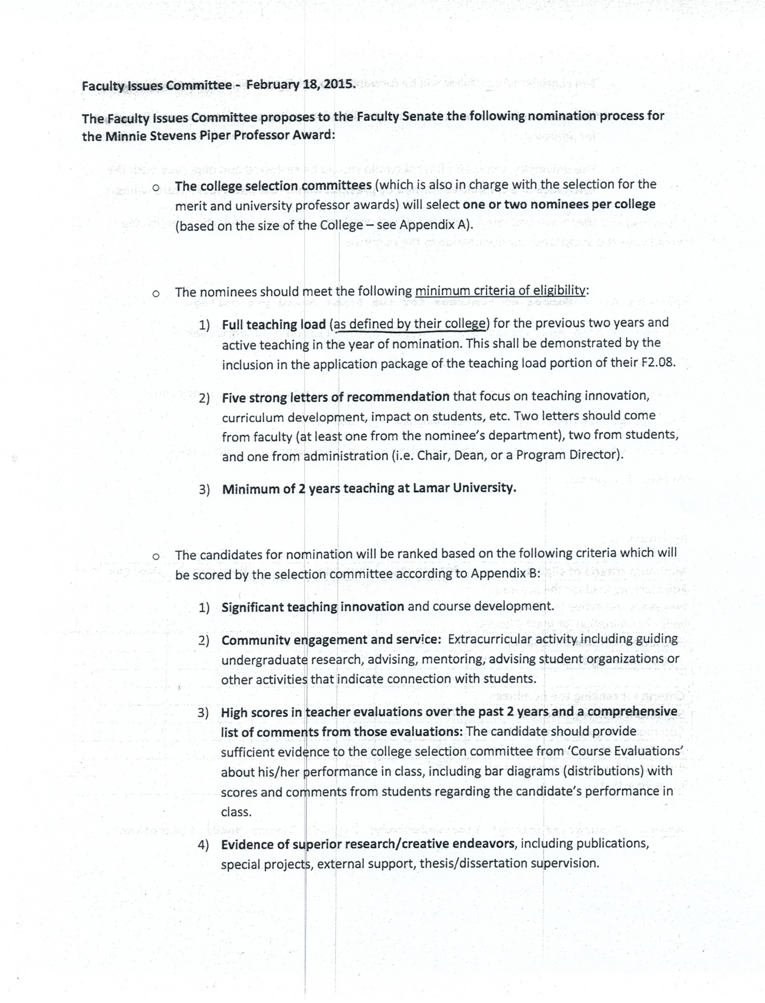

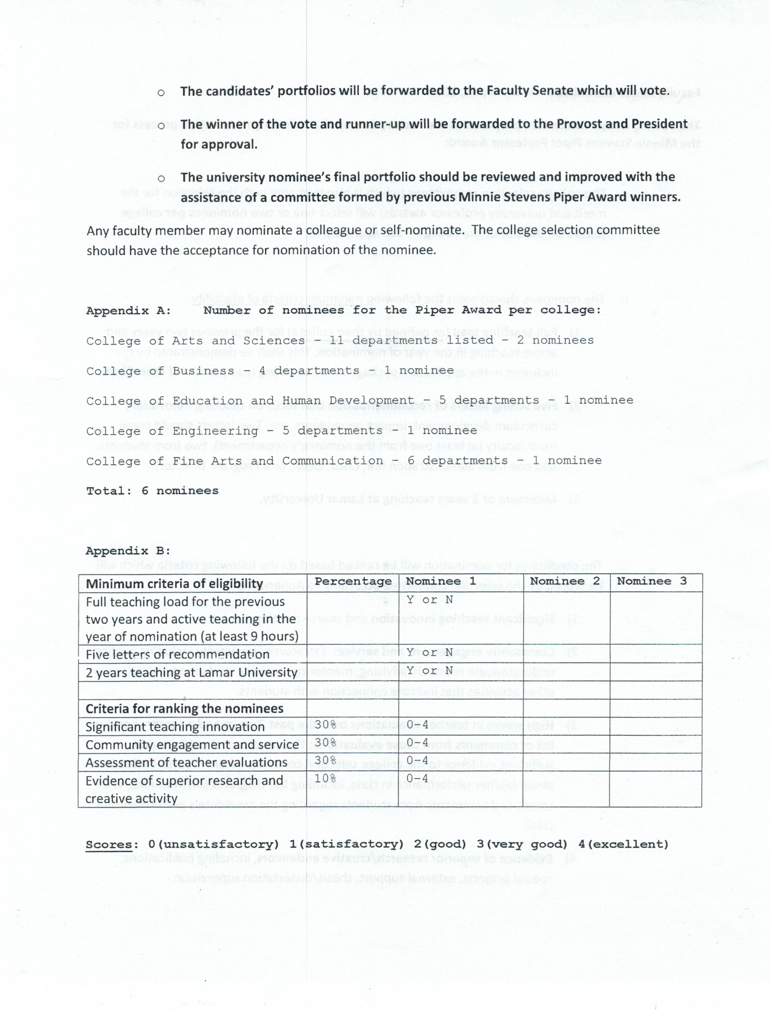
Appendix 2

Motion regarding Promotion to Full Professor:

Whereas Lamar University wishes to be in alignment with our sister schools, and
Whereas Lamar University wishes to attract and retain high caliber faculty, and
Whereas the Faculty Senate has been asked, by the faculty they represent,
to review and introduce changes as necessary to the tenure and promotion process,
We suggest the following wording and process be included in the Faculty Handbook regarding promotion to Full Professor:

A candidate is eligible to apply for promotion to Full Professor after the completion of five full years of service as an Associate Professor at Lamar University. Time served at another institution may be credited toward this number if contractually agreed upon at the time of hire. The application for promotion will be reviewed no earlier than the candidate’s sixth year of service as an Associate Professor. An applicant may choose to apply at a later time or not at all.

